- Realizar un programa Java serial y paralelo (usando hilos explícitos creados e instanciados en el programa) para solucionar el problema de la descomposición matricial QR de una matriz cuadrada NxN ($N=100K,K=1,2, . . . , 100$). Verificar que los resultados sean equivalentes y comparar los tiempos de ejecución.

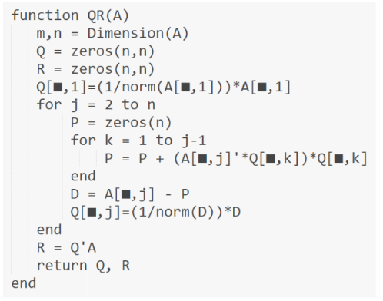

CLASE BASE MATRIZ.JAVA

public class Matrix {
private int ROWS;
private int COLS;
private double[][] M;
//------------------------------------------------------
//------------------------------------------------------
public Matrix(double[][] M) {
this.M = M;
this.ROWS = M.length;
this.COLS = M[0].length;
}
//------------------------------------------------------
//------------------------------------------------------
public double GetCell(int i, int j){
return M[i][j];
}
//------------------------------------------------------
//------------------------------------------------------
public void SetCell(int i, int j, double val){
M[i][j] = val;
}
//------------------------------------------------------
//------------------------------------------------------
public int getRows() {
return ROWS;
}
//------------------------------------------------------
//------------------------------------------------------
public int getCols() {
return COLS;
}
//------------------------------------------------------
//------------------------------------------------------
void imprimir() {
for (int i = 0; i < ROWS; i++) {
for (int j = 0; j < COLS; j++) {
System.out.printf("%12.2f", M[i][j]);
}
System.out.println();
}
}
//------------------------------------------------------
//------------------------------------------------------
public synchronized void incrementar(int fil, int col, double cant) {
M[fil][col] = M[fil][col] + cant;
}
//------------------------------------------------------
//------------------------------------------------------
public double prodEsc(int col1, int col2, int filIni, int filFin) {
double resp = 0;
for (int k = filIni; k <= filFin; k++) {
resp += (M[k][col1] * M[k][col2]);
}
return resp;
}
//------------------------------------------------------
//------------------------------------------------------
public double prodEsc(int col1, int col2) {
double resp = 0;
for (int k = 0; k < ROWS; k++) {
resp += (M[k][col1] * M[k][col2]);
}
return resp;
}
//------------------------------------------------------
//------------------------------------------------------
Matrix prod(Matrix B) {
int col = B.getCols();
Matrix C = new Matrix(new double[ROWS][col]);
for (int i = 0; i < ROWS; i++) {
for (int j = 0; j < col; j++) {
for (int k = 0; k < COLS; k++) {
double x = GetCell(i, k) * B.GetCell(k, j);
C.SetCell(i, j, C.GetCell(i, j) + x);
}
}
}
return C;
}
}

PROGRAMA QUE GENERA LOS DATOS
import java.io.FileNotFoundException;
import java.io.IOException;
import java.io.PrintWriter;
import java.nio.file.Path;
import java.nio.file.Paths;
import java.util.Random;
import java.util.Scanner;

//------------------------------------------------------
public class DataSet {
static int filas = 1000;
static int columnas = 1000;
static String DATAFILE = "Datos.TXT";
//------------------------------------------------------
public static void CreateFile(int M, int N) {
Random random = new Random();
PrintWriter pw = null;
try {
pw = new PrintWriter(DATAFILE);
for (int i = 0; i < M; i++) {
for (int j = 0; j < N; j++) {
double valor = random.nextDouble() * 100;
pw.printf("%10.2f", valor);
}
pw.println("");
}
} catch (FileNotFoundException ex) {
System.out.println(ex.getMessage());
} finally {
pw.close();
}
}
//------------------------------------------------------
public static double[][] ReadFile(int M, int N) {
double[][] MTX = new double[M][N];
Path filePath = Paths.get(DATAFILE);
Scanner scanner = null;
try {
scanner = new Scanner(filePath);
}
catch (IOException ex) {
System.out.println(ex.getMessage());
}
int i = 0, j = 0;
while (scanner.hasNext()) {
if (scanner.hasNextDouble()) {
MTX[i][j] = scanner.nextDouble();
j++;
if (j == N) {
j = 0;
i++;
}
}
else {
scanner.next();
}
}
return MTX;
}
//------------------------------------------------------
public static void WriteFile(Matrix M, String archivo){
int mm = M.getRows();
int nn = M.getCols();
PrintWriter pw = null;
try {
pw = new PrintWriter(archivo);
for (int i = 0; i < mm; i++) {
for (int j = 0; j < nn; j++) {
double valor = M.GetCell(i, j);
pw.printf("%10.2f", valor);
}
pw.println("");
}
}
catch (FileNotFoundException ex) {
System.out.println(ex.getMessage());
}
finally {
pw.close();
}
}
//------------------------------------------------------
public static void main(String[] args) {
Scanner scanner = new Scanner(System.in);
CreateFile(filas, columnas);
}
}

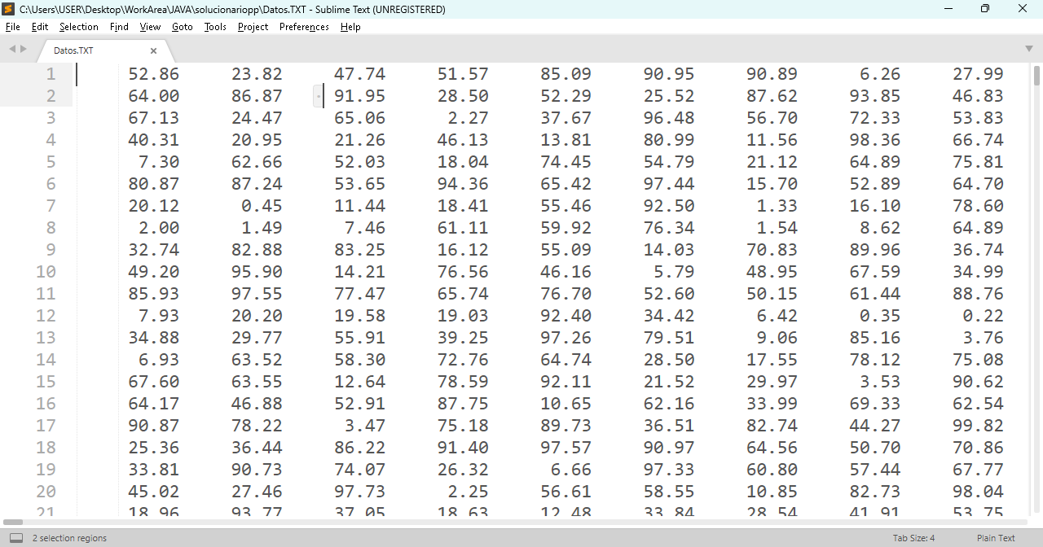

PROCESAMIENTO SERIAL
public class QR_Serial {
//--------------------------------------------------------------
//--------------------------------------------------------------
public static void Process_Serial() {
long Time1,Time2;
double x;
double[][] A1;
A1 = DataSet.ReadFile(DataSet.filas, DataSet.columnas);
Time1 = System.currentTimeMillis();
Matrix A = new Matrix(A1);
int filas = A.getRows();
int columnas = A.getCols();
Matrix R = new Matrix(new double[columnas][columnas]);
for (int i = 0; i < columnas; i++) {
for (int j = i; j < columnas; j++) {
x = A.prodEsc(i, j) / Math.sqrt(A.prodEsc(i, i));
R.SetCell(i, j, x);
}
for (int k = 0; k < filas; k++) {
x = A.GetCell(k, i) / R.GetCell(i, i);
A.SetCell(k, i, x);
}
for (int j = i + 1; j < columnas; j++) {
for (int k = 0; k < filas; k++) {
x = A.GetCell(k, j) - R.GetCell(i, j) * A.GetCell(k, i);
A.SetCell(k, j, x);
}
}
}
DataSet.WriteFile(A, "Matriz Q - Serial");
DataSet.WriteFile(R, "Matriz R - Serial");
Time2 = System.currentTimeMillis();
System.out.printf("Tiempo de Procesamiento Serial: %d%n", (Time2-Time1));
}
//--------------------------------------------------------------
//--------------------------------------------------------------
public static void main(String[] args) {
Process_Serial();
}
//--------------------------------------------------------------
//--------------------------------------------------------------
}//CLASS

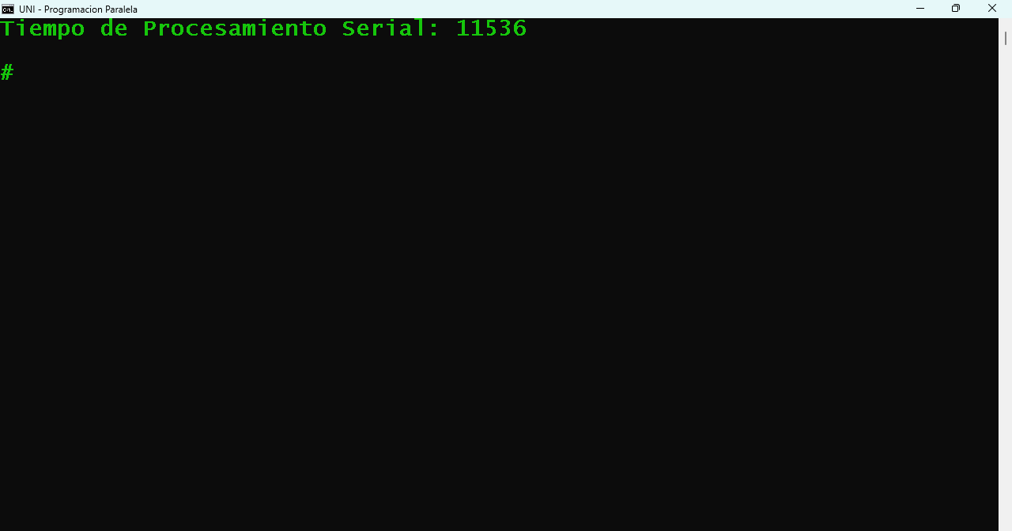

PROCESAMIENTO PARALELO
public class QR_Paralelo {
public static final int HILOS = 2;
//--------------------------------------------------------------
public static void main(String[] args) {
long Time1,Time2;
double[][] A1 = DataSet.ReadFile(DataSet.filas, DataSet.columnas);
Time1 = System.currentTimeMillis();
Matrix A = new Matrix(A1);
Matrix R = new Matrix(new double[A.getCols()][A.getCols()]);
for (int i = 0; i < A.getCols(); i++) {
Thread[] threads = new Thread[HILOS];
for (int t = 0; t < HILOS; t++) {
threads[t] = new Thread(new Oper1(t + 1, A, R, i));
threads[t].start();
}
try {
for (int t = 0; t < HILOS; t++) {
threads[t].join();
}
} catch (InterruptedException e) {
System.out.println(e.getMessage());
}
double x = Math.sqrt(R.GetCell(i, i));
for (int j = i; j < A.getCols(); j++) {
R.SetCell(i, j, R.GetCell(i, j) / x);
}
for (int t = 0; t < HILOS; t++) {
threads[t] = new Thread(new Oper2(t + 1, A, R, i));
threads[t].start();
}
try {
for (int t = 0; t < HILOS; t++) {
threads[t].join();
}
} catch (InterruptedException e) {
System.out.println(e.getMessage());
}
for (int t = 0; t < HILOS; t++) {
threads[t] = new Thread(new Oper3(t + 1, A, R, i));
threads[t].start();
}
try {
for (int t = 0; t < HILOS; t++) {
threads[t].join();
}
} catch (InterruptedException e) {

System.out.println(e.getMessage());
}
}
DataSet.WriteFile(A, "Matriz Q - Paralelo");
DataSet.WriteFile(R, "Matriz R - Paralelo");
Time2 = System.currentTimeMillis();
System.out.printf("Tiempo de Procesamiento Paralelo: %d%n", (Time2-Time1));
}
}
class Oper1 implements Runnable {
private Matrix A;
private Matrix R;
private int filIni;
private int filFin;
private int i;
public Oper1(int nroHilo, Matrix A, Matrix R, int i) {
this.A = A;
this.R = R;
filIni = (nroHilo - 1) * A.getRows() / QR_Paralelo.HILOS;
filFin = nroHilo * A.getRows() / QR_Paralelo.HILOS - 1;
this.i = i;
}
@Override
public void run() {
for (int j = i; j < A.getCols(); j++) {
R.incrementar(i, j, A.prodEsc(i, j, filIni, filFin));
}
}
}
class Oper2 implements Runnable {
private Matrix A;
private Matrix R;
private int filIni;
private int filFin;
private int i;
public Oper2(int nroHilo, Matrix A, Matrix R, int i) {
this.A = A;
this.R = R;
filIni = (nroHilo - 1) * A.getRows() / QR_Paralelo.HILOS;
filFin = nroHilo * A.getRows() / QR_Paralelo.HILOS - 1;
this.i = i;
}
@Override
public void run() {
double x = R.GetCell(i, i);
for (int k = filIni; k <= filFin; k++) {
A.SetCell(k, i, A.GetCell(k, i) / x);
}
}
}

class Oper3 implements Runnable {
private Matrix A;
private Matrix R;
private int filIni;
private int filFin;
private int i;
public Oper3(int nroHilo, Matrix A, Matrix R, int i) {
this.A = A;
this.R = R;
filIni = (nroHilo - 1) * A.getRows() / QR_Paralelo.HILOS;
filFin = nroHilo * A.getRows() / QR_Paralelo.HILOS - 1;
this.i = i;
}
@Override
public void run() {
for (int j = i + 1; j < A.getCols(); j++) {
double x = R.GetCell(i, j);
for (int k = filIni; k <= filFin; k++) {
A.SetCell(k, j, A.GetCell(k, j) - x * A.GetCell(k, i));
}
}
}
}

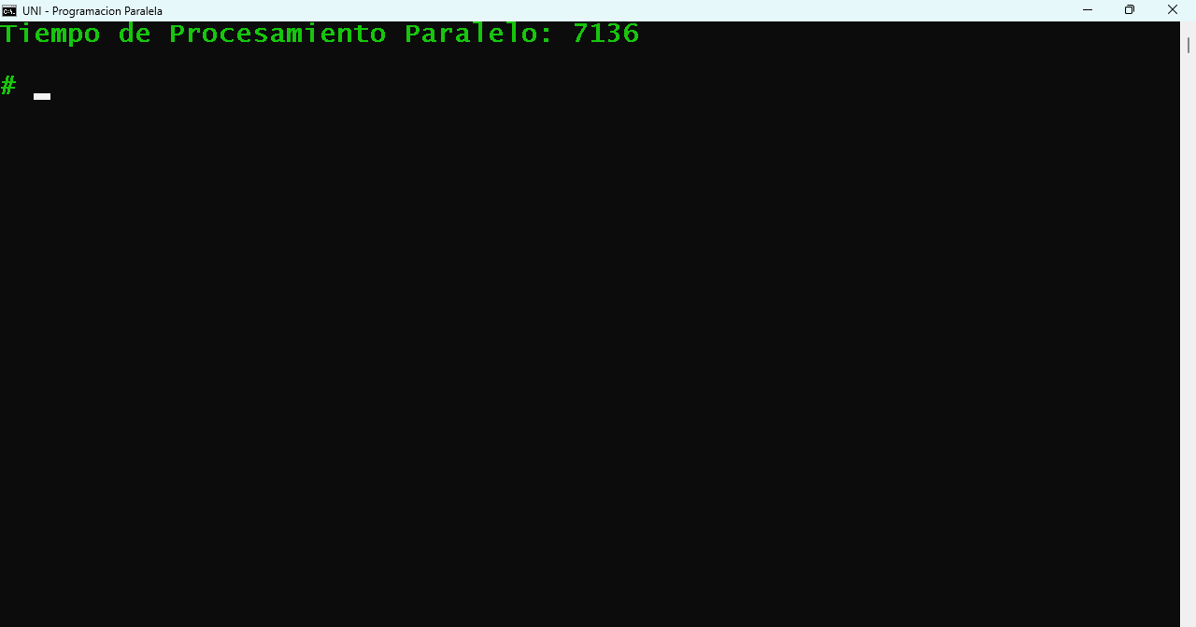

Al procesar los programas anteriores (Serial y Paralelo) se crearon los siguientes archivos

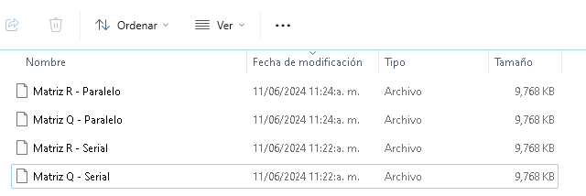

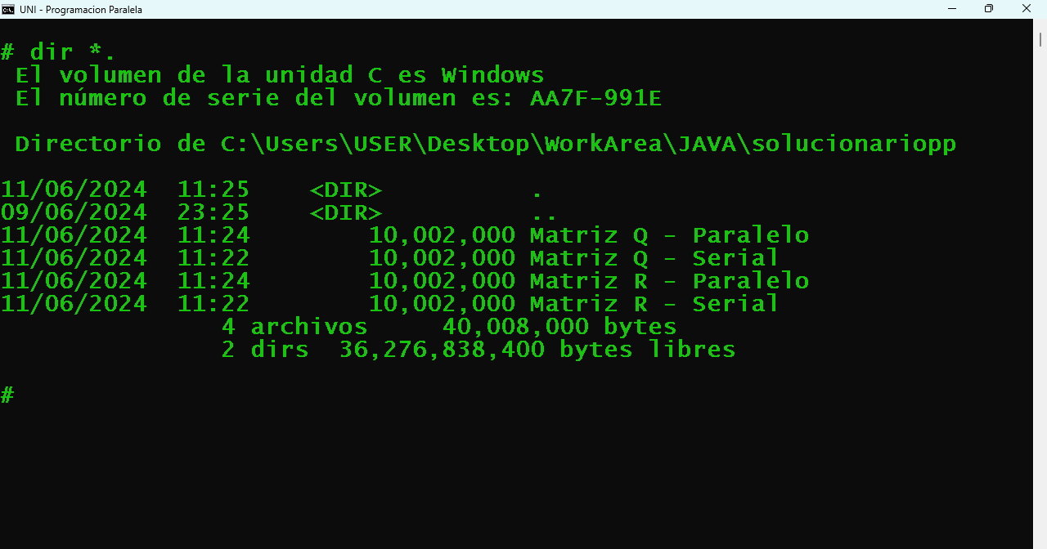

Comparando los archivos generados en modo serial y paralelo

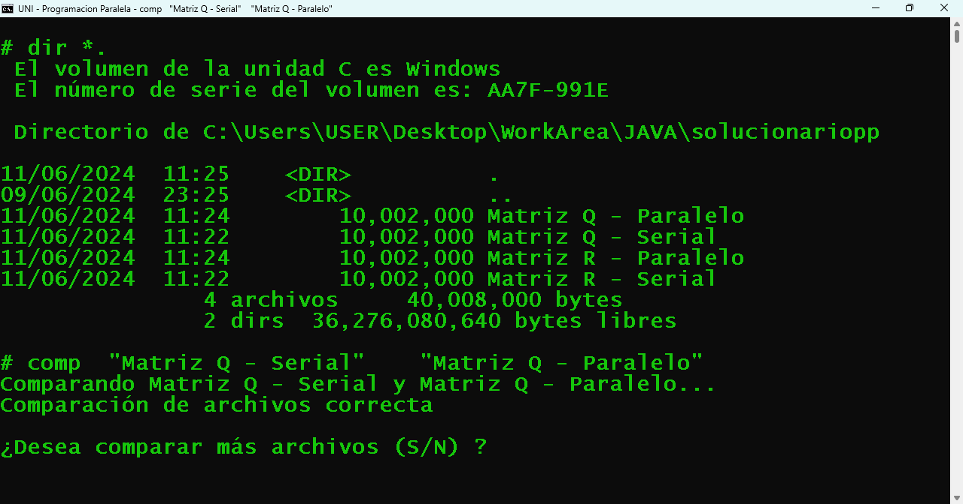

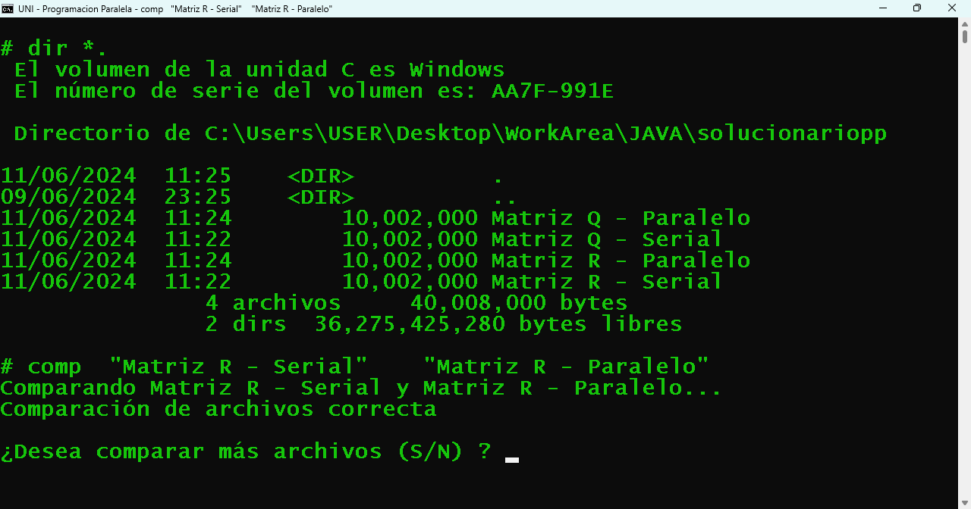
Se verifica que son iguales

- Dados N procesadores (cores) P₁, P₂, .... P_{N}, los tiempos de ejecución requeridos por cada uno de ellos para realizar el procesamiento serial de una determinada tarea (proceso) son $T_{S}^{(1)}, T_{S}^{(2)}, . . . . . , T_{S}^{(N)}$.
Por tanto, el tiempo promedio de ejecución serial es
$\underline{T_{S}}=\frac{\sum_{i=k}^{N}{}T_{S}^{(k)}}{N}=\frac{T_{S}}{N}$
Luego, la proporción de ejecución serial para cada uno de los N procesadores es
$P_{S}^{(k)}=\frac{T_{S}^{(k)}}{\underline{T_{S}}},$ $k=1,2,3, . . . N$
Sea $T_{P}$ el tiempo requerido para la ejecución de la misma tarea en modo paralelo usando los N procesadores. El Factor de Aceleración (Speedup Factor) de ejecución paralela, respecto a cada procesador está dado por:
$P_{P}^{(k)}=\frac{T_{S}^{(k)}}{\underline{T_{P}}},$ $k=1,2,3, . . . N$
Efectuar un programa Java que determine estas métricas para el problema de multiplicación de matrices A y B.

Se ha considerado n=4 procesadores.
El proceso a realizar es el producto matricial de 2 matrices cuadradas A y B de orden N=1000
para tal efecto se han considerado los siguientes programas

Process_Task.JAVA
Librería que contiene métodos genéricos usados en los otros programas de procesamiento serial, paralelo y por hilos.
import java.io.File;
import java.io.PrintWriter;
import java.io.FileNotFoundException;
import java.util.Scanner;
import java.util.Random;

public class Process_Task {
private int N;
private final int HH = 10; //Block Size
//=====================================================
public Process_Task() {
N = 0;
}
//=====================================================
public Process_Task(int T) {
N = T;
}
//=====================================================
public String Replicate(char EE, int T) {
String SS;
SS = "";
for(int i=0;i<=T-1;i++) {
SS = SS + EE;
}
return SS;
}
//=====================================================
public int[] GetDimensionFile(String DATAFILE) {
int DIM[] = {0,0};
String LINE;
try {
File FILE = new File(DATAFILE);
Scanner SCN = new Scanner(FILE);
DIM[0] = 0;
while(SCN.hasNextLine()) {
LINE = SCN.nextLine();
DIM[0]++;
DIM[1] = LINE.length()/HH;
}
SCN.close();
}
catch (FileNotFoundException e) {
System.out.println("An error occurred.");
e.printStackTrace();
}
return DIM;
}
//=====================================================
public int GetDimensionMatrix() {
return N;
}
//=====================================================
public void SetDimensionMatrix(int T) {
N = T;
}
//=====================================================
public void PrintRandomMatrix(int[][] MTX, String TITLE) {
System.out.println("\n" + TITLE);
System.out.println(Replicate('-',TITLE.length()));
for(int i=0;i<=N-1;i++) {
for(int j=0;j<=N-1;j++) {
System.out.print(MTX[i][j] + "\t");
}
System.out.println();
}
}
//=====================================================
public int[][] CreateRandomMatrix(int T) {
int MTX[][] = new int[N][N];
Random RDM = new Random();
N = T;
for(int i=0;i<=N-1;i++) {
for(int j=0;j<=N-1;j++) {
MTX[i][j] = 10 + RDM.nextInt(90);
}
}
return MTX;
}
//=====================================================
public void CreateFileMatrix(String DATAFILE, int T) {
Random RDM = new Random();
PrintWriter PW = null;
long EE;
String SS;
N = T;
try {
PW = new PrintWriter(DATAFILE);
for(int i=0;i<=N-1;i++) {
for(int j=0;j<=N-1;j++) {
EE = 10 + RDM.nextInt(90);
SS = "" + EE + "";
PW.print(Replicate(' ',HH-SS.toString().length()) + SS);
}
PW.println("");
}
}
catch(FileNotFoundException ex) {
System.out.println(ex.getMessage());
}
finally {
PW.close();
}
}
//=====================================================
public int[][] ReadFileMatrix(String DATAFILE) {
int MTX[][] = new int[N][N];
int i,j,LL;
String LINE;
try {
File FILE = new File(DATAFILE);
Scanner SCN = new Scanner(FILE);
i = 0;
while(SCN.hasNextLine()) {
LINE = SCN.nextLine();
LL = LINE.length();
j = 0;
while(HH*j<=LL-1) {
MTX[i][j] = Integer.parseInt(LINE.substring(HH*j,HH*j+HH).trim());
j++;
}
i++;
}
SCN.close();
}
catch (FileNotFoundException e) {
System.out.println("An error occurred.");
e.printStackTrace();
}
return MTX;
}
//=====================================================
}

Process_InputData.java
Programa que genera datos en un archivo.

import java.util.Scanner;

public class Process_InputData {
private static Process_Task TSK = new Process_Task();
//================================================================
public static void GenerarData() {
int M,N;
Scanner SCN = new Scanner(System.in);
System.out.println("==============================");
System.out.println("Creacion de DataSet en Archivo");
System.out.println("==============================");
System.out.print ("Ingrese Numero de Filas/Columnas: ");
N = SCN.nextInt();
TSK.CreateFileMatrix("A.TXT",N);
TSK.CreateFileMatrix("B.TXT",N);
}
//================================================================
public static void main(String[] args) {
GenerarData();
}
//================================================================
}

Process_Serial.java
Procesamiento Serial del Producto Matricial

import java.util.concurrent.atomic.AtomicInteger;

public class Process_Serial {
private static Process_Task TSK = new Process_Task();
private static int N;
private static int[][] A;
private static int[][] B;
private static long[][] C;
//================================================================
public static void Calcular_AxB() {
for(int i=0;i<=N-1;i++) {
for(int j=0;j<=N-1;j++) {
C[i][j] = 0;
for(int k=0;k<=N-1;k++) {
C[i][j] = C[i][j] + A[i][k]*B[k][j];
}
}
}
}
//================================================================
public static void Imprimir_AxB() {
System.out.println("\nMatriz AxB - Proceso Serial");
System.out.println("---------------------------");
for(int i=0;i<=N-1;i++) {
for(int j=0;j<=N-1;j++) {
System.out.print(C[i][j] + "\t");
}
System.out.println();
}
}
//================================================================
public static void main(String[] args) {
int[] Dim_A = TSK.GetDimensionFile("A.TXT");
int[] Dim_B = TSK.GetDimensionFile("B.TXT");
long Time1,Time2,TIME_SERIAL;
if((Dim_A[0]==Dim_A[1])&&
(Dim_B[0]==Dim_B[1])&&
(Dim_A[1]==Dim_B[0])) {
N = Dim_A[0];
TSK.SetDimensionMatrix(N);
A = TSK.ReadFileMatrix("A.TXT");
B = TSK.ReadFileMatrix("B.TXT");
C = new long[N][N];
Time1 = System.currentTimeMillis();
Calcular_AxB();
Time2 = System.currentTimeMillis();
TIME_SERIAL = Time2 - Time1;
System.out.println("Tiempo de Proceso Serial: " + TIME_SERIAL);
}
else {
System.out.println("Error en Dimension en Archivo de Datos");
}
}
//================================================================
}

Process_Parallel.java
Procesamiento Paralelo del Producto Matricial

import java.util.concurrent.atomic.AtomicInteger;

public class Process_Parallel {
private static Process_Task TSK = new Process_Task();
private static int N;
private static int T;
private static long Time1,Time2,TIME_PARALLEL;

private static boolean Sw1 = false;
private static boolean Sw2 = false;
private static boolean Sw3 = false;
private static boolean Sw4 = false;

private static int[][] A;
private static int[][] B;
private static long[][] C;
//================================================================
public static void Salida_Hilos() {
if((Sw1&&Sw2&&Sw3&&Sw4)==true) {
Time2 = System.currentTimeMillis();
TIME_PARALLEL = Time2 - Time1;
System.out.println("Tiempo de Proceso Paralelo: " + TIME_PARALLEL);
}
}
//================================================================
public static void SubProceso_Hilo1() {
new Thread(new Runnable() {
public void run() {
Calcular_AxB(0,T,0,T);
Sw1 = true;
Salida_Hilos();
}
}).start();
}
//================================================================
public static void SubProceso_Hilo2() {
new Thread(new Runnable() {
public void run() {
Calcular_AxB(0,T,T+1,N-1);
Sw2 = true;
Salida_Hilos();
}
}).start();
}
//================================================================
public static void SubProceso_Hilo3() {
new Thread(new Runnable() {
public void run() {
Calcular_AxB(T+1,N-1,0,T);
Sw3 = true;
Salida_Hilos();
}
}).start();
}
//================================================================
public static void SubProceso_Hilo4() {
new Thread(new Runnable() {
public void run() {
Calcular_AxB(T+1,N-1,T+1,N-1);
Sw4 = true;
Salida_Hilos();
}
}).start();
}
//================================================================
public static void Calcular_AxB(int R1, int R2, int C1, int C2) {
for(int i=R1;i<=R2;i++) {
for(int j=C1;j<=C2;j++) {
C[i][j] = 0;
for(int k=0;k<=N-1;k++) {
C[i][j] = C[i][j] + A[i][k]*B[k][j];
}
}
}
}
//================================================================
public static void Imprimir_AxB() {
System.out.println("\nMatriz AxB - Proceso Paralelo");
System.out.println("---------------------------");
for(int i=0;i<=N-1;i++) {
for(int j=0;j<=N-1;j++) {
System.out.print(C[i][j] + "\t");
}
System.out.println();
}
}
//================================================================
public static void main(String[] args) throws InterruptedException {
int[] Dim_A = TSK.GetDimensionFile("A.TXT");
int[] Dim_B = TSK.GetDimensionFile("B.TXT");
if((Dim_A[0]==Dim_A[1])&&
(Dim_B[0]==Dim_B[1])&&
(Dim_A[1]==Dim_B[0])) {
N = Dim_A[0];
TSK.SetDimensionMatrix(N);
T = (int)(N/2)-1;
A = TSK.ReadFileMatrix("A.TXT");
B = TSK.ReadFileMatrix("B.TXT");
C = new long[N][N];
Time1 = System.currentTimeMillis();
SubProceso_Hilo1();
SubProceso_Hilo2();
SubProceso_Hilo3();
SubProceso_Hilo4();
}
else {
System.out.println("Error en Dimension en Archivo de Datos");
}
}
//================================================================
}

Process_Threads.java
Procesamiento en cada hilo (Thread) del Producto Matricial.
Se han considerado n=4 hilos

import java.util.concurrent.atomic.AtomicInteger;

public class Process_Threads {
private static Process_Task TSK = new Process_Task();
private static int N;
private static long Time11 = 0;
private static long Time12 = 0;
private static long Time21 = 0;
private static long Time22 = 0;
private static long Time31 = 0;
private static long Time32 = 0;
private static long Time41 = 0;
private static long Time42 = 0;
private static long TIME_THREAD1=0;
private static long TIME_THREAD2=0;
private static long TIME_THREAD3=0;
private static long TIME_THREAD4=0;
private static int[][] A;
private static int[][] B;
private static long[][] C1;
private static long[][] C2;
private static long[][] C3;
private static long[][] C4;
//================================================================
public static void Calcular_AxB(long C[][]) {
for(int i=0;i<=N-1;i++) {
for(int j=0;j<=N-1;j++) {
C[i][j] = 0;
for(int k=0;k<=N-1;k++) {
C[i][j] = C[i][j] + A[i][k]*B[k][j];
}
}
}
}
//================================================================
//================================================================
public static void SubProceso_Hilo1(long C1[][]) {
new Thread(new Runnable() {
public void run() {
Time11 = System.currentTimeMillis();
Calcular_AxB(C1);
Time12 = System.currentTimeMillis();
TIME_THREAD1 = Time12 - Time11;
System.out.println("Tiempo de Proceso Hilo 1: " + TIME_THREAD1);
}
}).start();
}
//================================================================
public static void SubProceso_Hilo2(long C2[][]) {
new Thread(new Runnable() {
public void run() {
Time21 = System.currentTimeMillis();
Calcular_AxB(C2);
Time22 = System.currentTimeMillis();
TIME_THREAD2 = Time22 - Time21;
System.out.println("Tiempo de Proceso Hilo 2: " + TIME_THREAD2);
}
}).start();
}
//================================================================
public static void SubProceso_Hilo3(long C3[][]) {
new Thread(new Runnable() {
public void run() {
Time31 = System.currentTimeMillis();
Calcular_AxB(C3);
Time32 = System.currentTimeMillis();
TIME_THREAD3 = Time32 - Time31;
System.out.println("Tiempo de Proceso Hilo 3: " + TIME_THREAD3);
}
}).start();
}
//================================================================
public static void SubProceso_Hilo4(long C4[][]) {
new Thread(new Runnable() {
public void run() {
Time41 = System.currentTimeMillis();
Calcular_AxB(C4);
Time42 = System.currentTimeMillis();
TIME_THREAD4 = Time42 - Time41;
System.out.println("Tiempo de Proceso Hilo 4: " + TIME_THREAD4);
}
}).start();
}
//================================================================
public static void main(String[] args) throws InterruptedException {
int[] Dim_A = TSK.GetDimensionFile("A.TXT");
int[] Dim_B = TSK.GetDimensionFile("B.TXT");
if((Dim_A[0]==Dim_A[1])&&
(Dim_B[0]==Dim_B[1])&&
(Dim_A[1]==Dim_B[0])) {
N = Dim_A[0];
TSK.SetDimensionMatrix(N);
A = TSK.ReadFileMatrix("A.TXT");
B = TSK.ReadFileMatrix("B.TXT");
C1 = new long[N][N];
C2 = new long[N][N];
C3 = new long[N][N];
C4 = new long[N][N];
SubProceso_Hilo1(C1);
SubProceso_Hilo2(C2);
SubProceso_Hilo3(C3);
SubProceso_Hilo4(C4);
}
else {
System.out.println("Error en Dimension en Archivo de Datos");
}
}
//================================================================
}

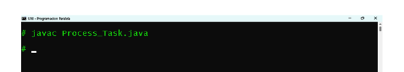

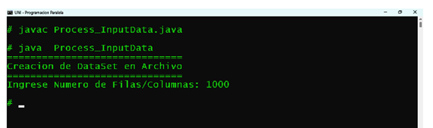

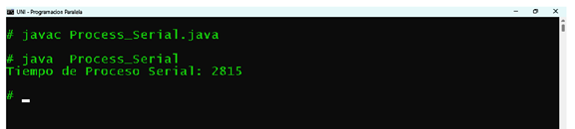

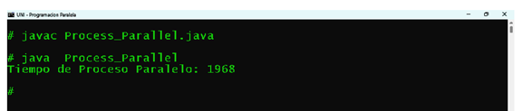

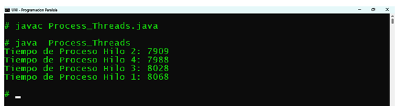

Luego con los valores de los tiempos obtenidos se determina la solución del problema

GESTIÓN DE PROCESOS

PROCESO = TAREA

Un Proceso es la instancia de un Programa

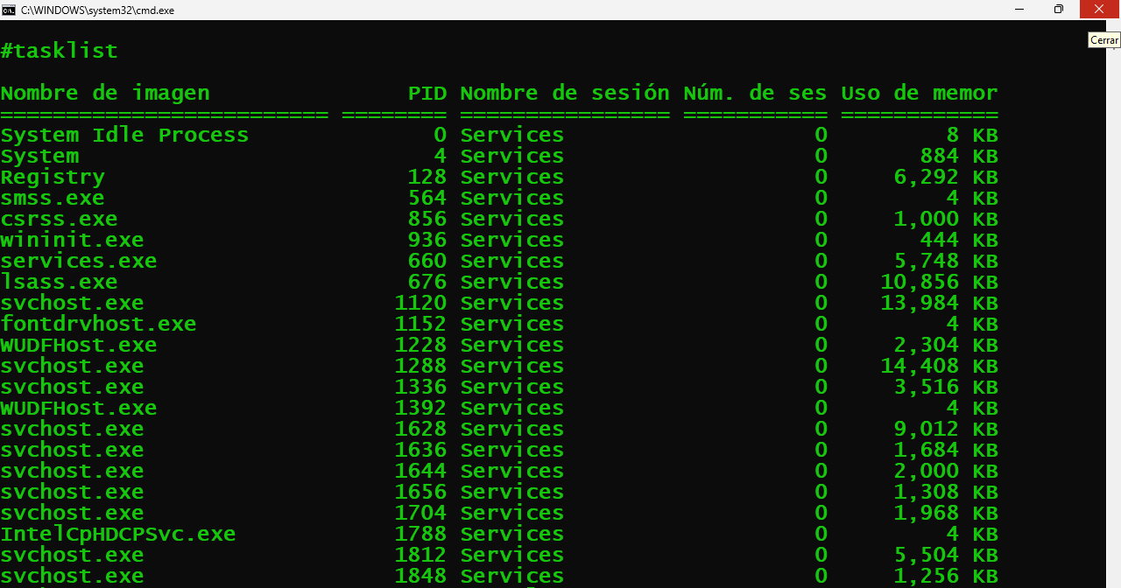

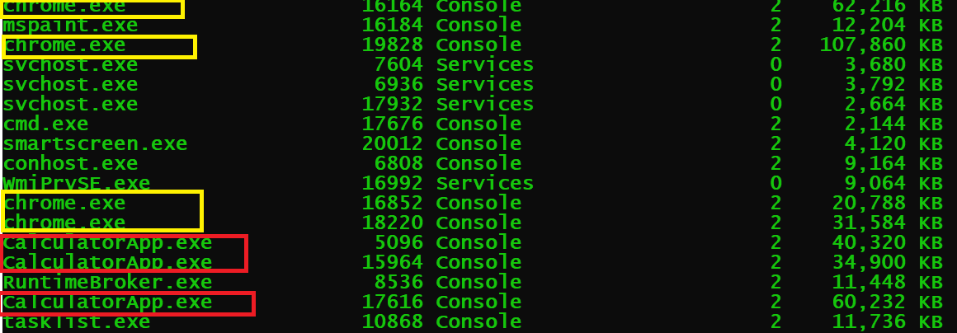

JERARQUÍA DE PROCESOS

Un proceso tiene sub-procesos
Un sub-proceso tiene sub-sub-procesos

Luego:
Un sub-proceso es un proceso
Un sub-sub-proceso es un proceso

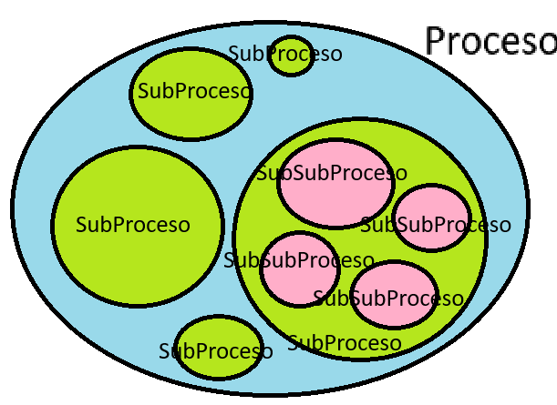

Un Proceso tiene una estructura
- Id
- Name
- Tamaño en Bytes
- Status
- Cuota de Tiempo en milisegundos
- Prioridad

Los procesos se organizan en una estructura de datos (FIFO) y compiten entre si para usar el procesador (o procesadores)

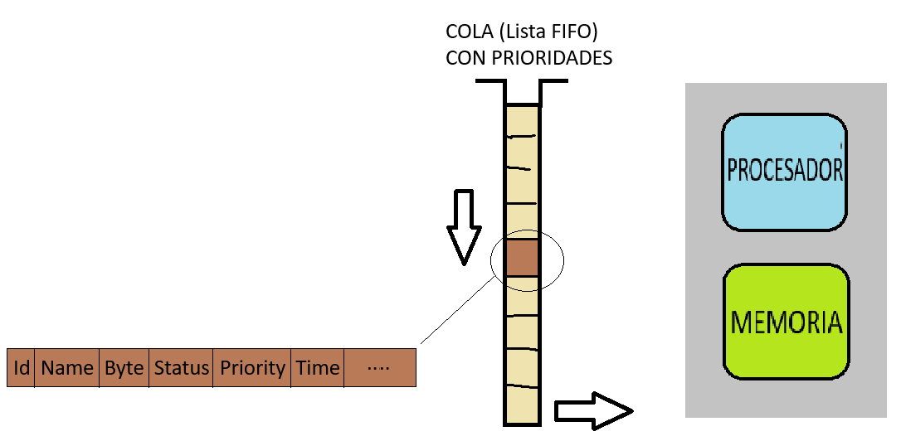

Cómo podría el SO asumir la prioridad de un proceso?
- Tamaño en Bytes del Proceso
- Estado del proceso (READY, WAIT, RUN, CANCEL,FINISH)
- Tamaño de la Cuota de Tiempo asignado

■■■■■■■■■■■■■■■■■■■■■■■■■■■■■■■■■■■■■■■■■■■■■■■■

Asignar Prioridades al TaskList (TL)

┌ PROCEDURE AssignPriority()
│
│ A = TL[1].Size
│ B = TL[1].Size
│ ┌ FOR i = 1 TO N
│ │ ┌ IF TL[i].Size < A
│ │ │ A = TL[i].Size
│ │ └ END-IF
│ │ ┌IF B < TL[i].Size
│ │ │ B = TL[i].Size
│ │ └END-IF
│ └ END-FOR
│ H = (B-A)/3
│ //Se definen los hitos A=A+0H, A+1H, A+2H, A+3H=B
│ ┌ FOR i = 1 TO N
│ │ ┌ IF TL[i].Size < A+1H
│ │ │ TL[i].Priority = 1
│ │ ├ ELSEIF TL[i].Size < A+2H
│ │ │ TL[i].Priority = 2
│ │ ├ELSE
│ │ │ TL[i].Priority = 3
│ │ └ END-IF
│ └ END-FOR
│
└ END-PROCEDURE

La lista o tabla de procesos es una estructura dinámica porque los nuevos procesos están ingresando para ser almacenados en memoria y ser ejecutados por el procesador; y tambien existen procesos que han finalizado su ejecución.

Se va implementar un modelo dinámico basado en una estructura de lista enlazada simple que posee 2 punteros, al inicio y al final.

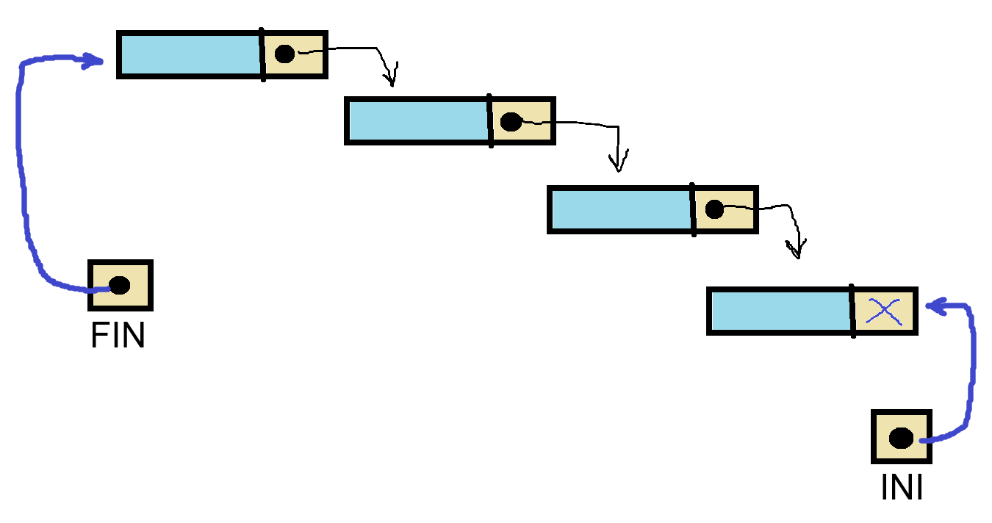

PROCEDURE AdicionarProceso()
PTR= NEW(NODO)
PTR^.NEXT = FIN
FIN = PTR
END

PROCEDURE ObtenerMaximaPrioridad()
PTR = INI
AUX= INI
WHILE PTR != NULL
IF AUX^.PRIORITY < PTR^.PRIORITY
AUX = PTR
END
PTR = PTR^.NEXT
END
RETURN PP
END

PROCEDURE ObtenerMinimaPrioridad()
PTR = INI
AUX= INI
WHILE PTR != NULL
IF PTR^.PRIORITY < AUX^.PRIORITY
AUX = PTR
END
PTR = PTR^.NEXT
END
RETURN PP
END

PROCEDURE AssignPriority()

Transicion de Estados de Procesos

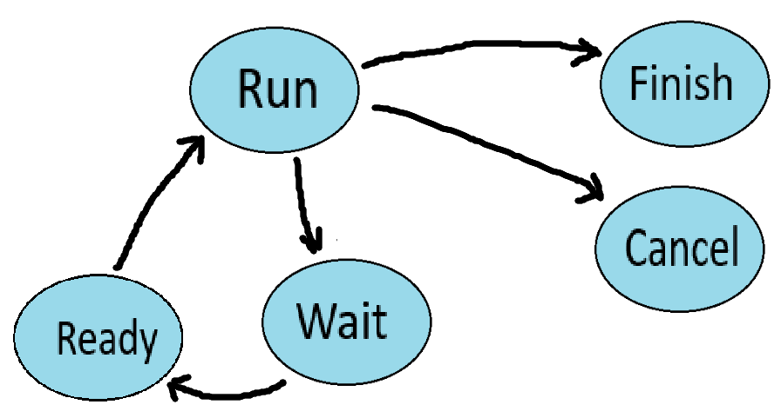

¿Cómo es posible que varios programas se ejecuten de manera concurrente????

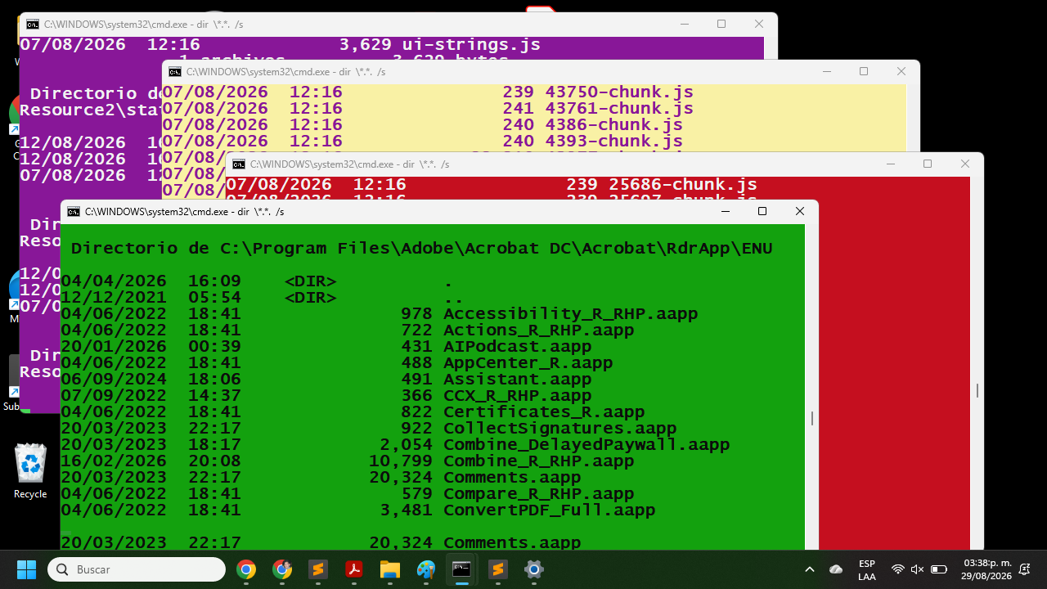

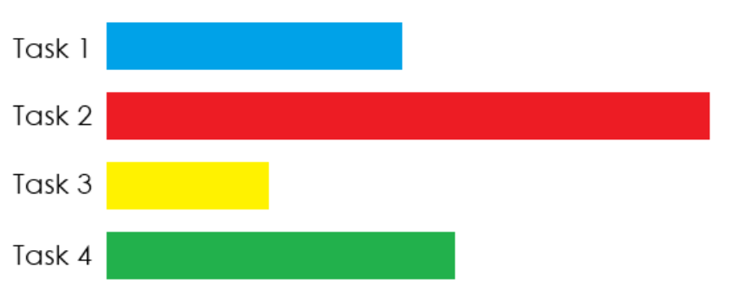

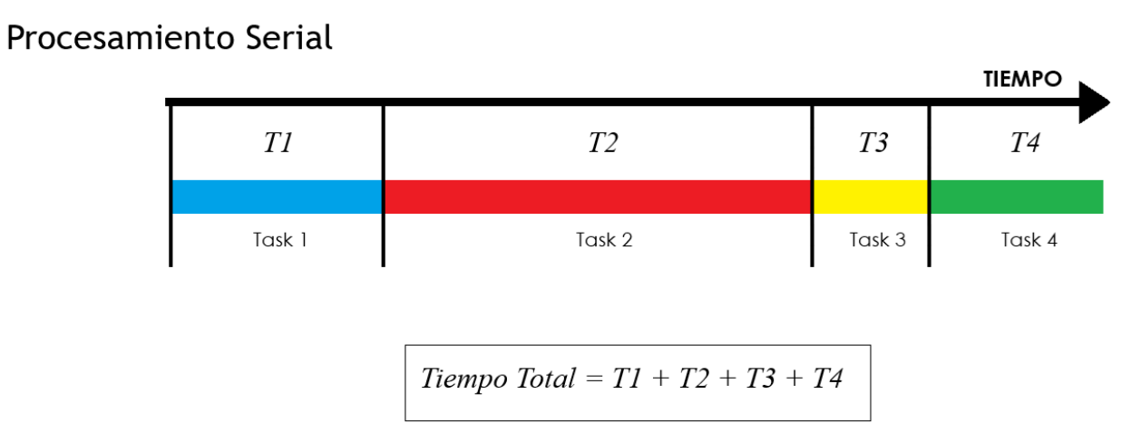

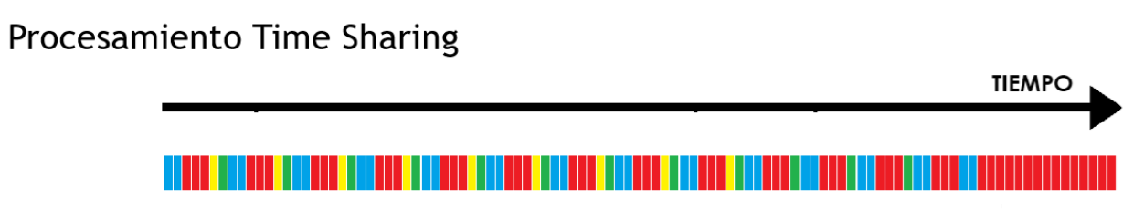

TRABAJO DE APLICACIÓN

Sea el sistema

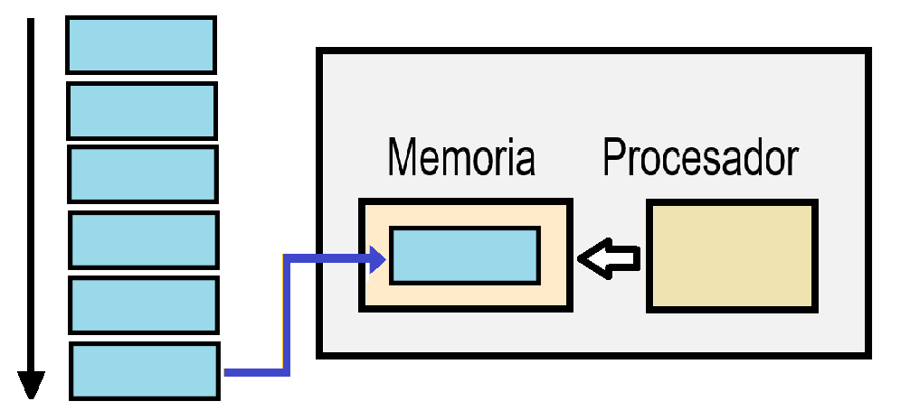

Grafos de Dependencia de Tareas

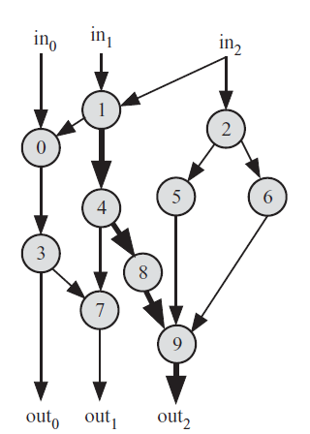

import java.io.BufferedReader;
import java.io.FileReader;
import java.io.FileWriter;
import java.io.IOException;

public class TaskDependency {

private static final int M=1000;
private static final int N=10;

private static int[][] A = new int[M+1][N+1];
private static int[][] B = new int[M+1][N+1];

private static boolean Sw1;
private static boolean Sw2;

private static boolean Sw5;
private static boolean Sw6;

//-----------------------------------------------
//-----------------------------------------------
public static void WriteData(String DATAFILE, int M, int N, int A, int B, int R) {
FileWriter FW;
int H;
try {
FW = new FileWriter(DATAFILE);
for(int i=1;i<=M;i++) {
for(int j=1;j<=N;j++) {
H = A + R*(int)(Math.random()*(1+(B-A)/R));
FW.write(H + (j<N?";":""));
}
FW.write("\n");
}
FW.close();
}
catch(IOException E) {
}
}
//-----------------------------------------------
public static void main(String args[]) throws InterruptedException {
Sw1 = false;
Sw2 = false;
//----------------------------------------
new Thread(new Runnable() {
public void run() {
WriteData("DataFile_1.txt",1000,50,1000,9750,250);
Sw1 = true;
}
}).start();
//----------------------------------------
//----------------------------------------
new Thread(new Runnable() {
public void run() {
Sw5 = false;
Sw6 = false;
WriteData("DataFile_2.txt",10000,120,10,300,5);
Sw2 = true;
//- - - - - - - - - - - - - - - - - - - - - - - -
//- - - - - - - - - - - - - - - - - - - - - - - -
new Thread(new Runnable() {
public void run() {
System.out.println("Proceso 5");
Sw5 = true;
}
}).start();
//- - - - - - - - - - - - - - - - - - - - - - - -
new Thread(new Runnable() {
public void run() {
System.out.println("Proceso 6");
Sw6 = true;
}
}).start();
//- - - - - - - - - - - - - - - - - - - - - - - -
//- - - - - - - - - - - - - - - - - - - - - - - -
do {
} while((Sw5==false)||(Sw6==false));
//- - - - - - - - - - - - - - - - - - - - - - - -
//- - - - - - - - - - - - - - - - - - - - - - - -
}
}).start();
//----------------------------------------
//----------------------------------------
do {
Thread.sleep(100);
} while((Sw1==false)||(Sw2==false));
//----------------------------------------
//----------------------------------------
System.out.println(Sw1);
System.out.println(Sw2);

}
//-----------------------------------------------
}

